The purpose of max pooling is enabling the convolutional neural network to detect the object(face, car, cheetha) when presented with the image in any manner(In different location: location-invariant, different size: scale-invariant, different angles: rotation-invariant)

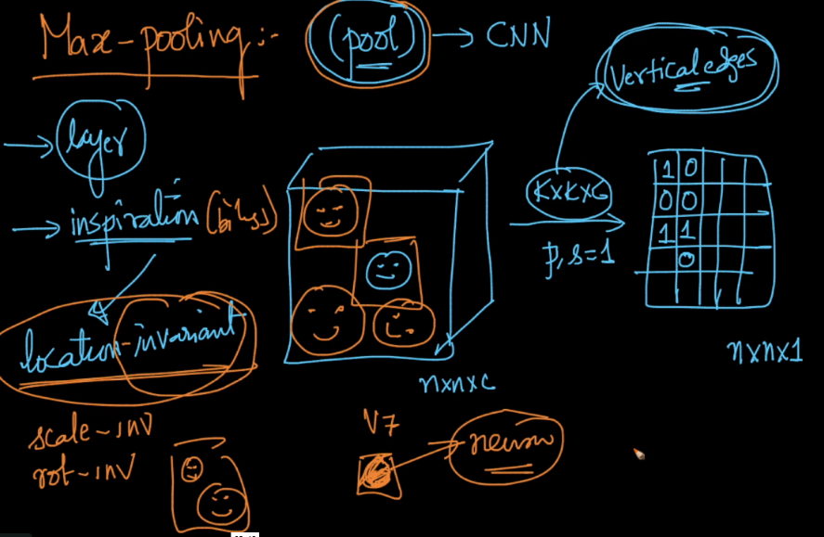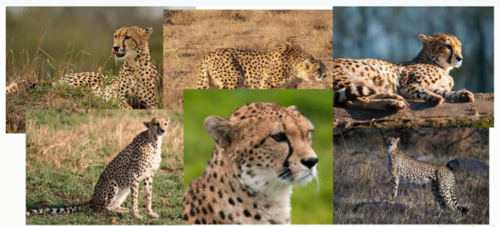

How max-pooling is performed:

Let’s say we’ve a kernel of 2\*2 and using stride with s=2 and i/p image is of 4\*4.

Now we apply the kernel on first quarter of image [1,1,5,6], now we find max of them which is 6, so we store 6 in first cell of o/p image.

Apply kernel on 2nd quareter because stride=2, need to shift by 2 step ie [2, 4, 7, 8], and max is 8, so in 2nd cell of o/p we store 8

Similarly for 3 cell we store 3 and for 4th cell we store 4. (first example in below image)

Below image also shows an example with stride=1.

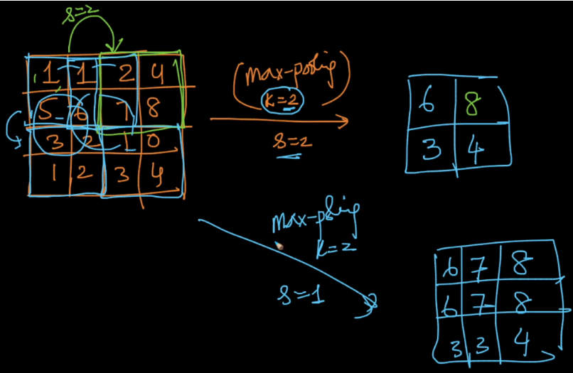

So how does max pooling work, currently kernel is of 2\*2, therefore if edge is present in any of the 4 cell the neuron become active because it’s value is specified with the highest value among 4 cells.

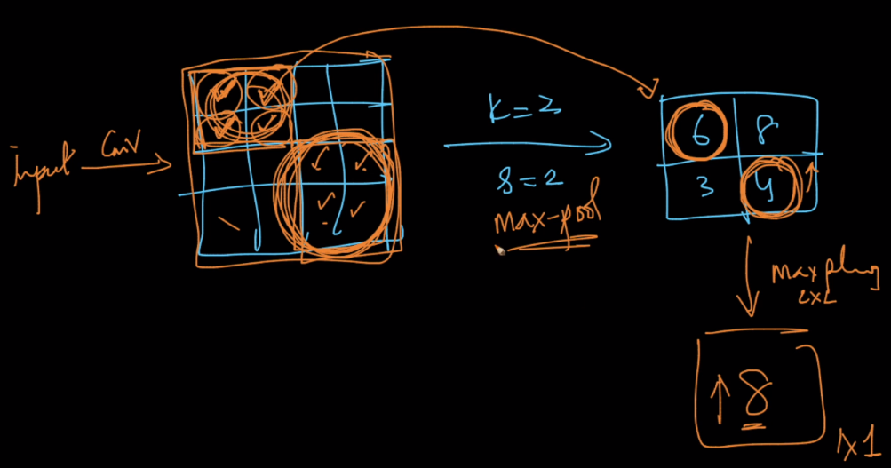

<http://adventuresinmachinelearning.com/convolutional-neural-networks-tutorial-tensorflow/>

